Watermelon Amaro Pops
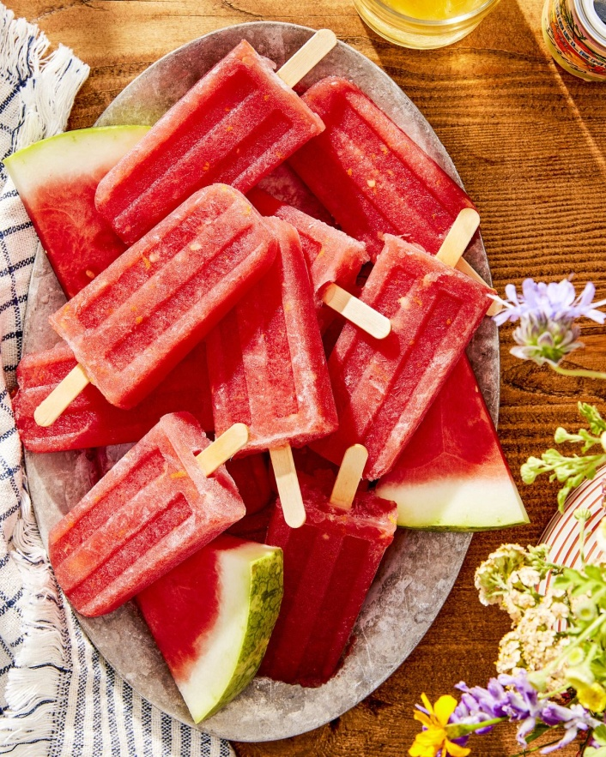
DSCRIPTION:
Who doesn't love a cold, boozy treat on a hot day? These easy-to-make pops blend fresh watermelon with a touch of orange liqueur for a decidedly grown-up dessert.

INGREDIENTS
2 lb. watermelon, cubed (8 cups)
1/2 c. Amaro Angeleno or other orange-flavored liqueur
5 tbsp. light agave syrup
1 1/2 tbsp. orange zest plus 1/2 cup juice
2 tbsp. fresh lime juice
Wooden sticks

INSTRUCTIONS:
Step 1
Process watermelon in a blender until smooth. Add liqueur, agave, orange zest and juice, and lime juice. Process on low just until combined, about 1 minute.
Step 2
Pour liquid into 12 (3-ounce) ice pop molds, dividing evenly. Add wooden sticks to molds. Freeze until solid, at least 8 hours.

CALORIES:
Water: 91%
Protein: 0.6 g
Carbs: 7.6 g
Sugar: 6.2 g
Fiber: 0.4 g
Fat: 0.2 g

